Python Programs on Functional Programming

1. Using map() to Find Squares of Numbers
# Program to find squares using map()
numbers = [1, 2, 3, 4, 5]
squares = list(map(lambda x: x * x, numbers))
print("Original List:", numbers)
print("Squares List:", squares)

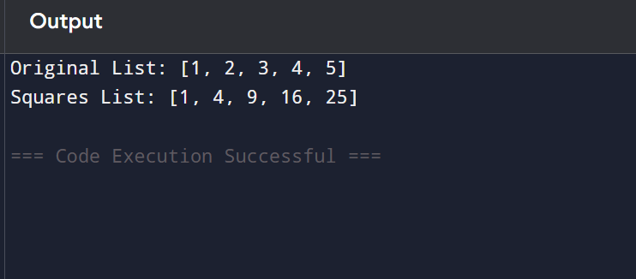

2. Using filter() to Find Even Numbers
# Program to filter even numbers
numbers = [10, 15, 20, 25, 30, 35, 40]
even_numbers = list(filter(lambda x: x % 2 == 0, numbers))
print("Original List:", numbers)
print("Even Numbers:", even_numbers)

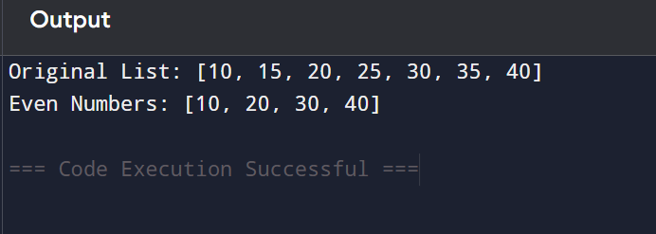

3. Using reduce() to Find Sum of Elements
# Program to find sum using reduce()
from functools import reduce
numbers = [1, 2, 3, 4, 5]
sum_result = reduce(lambda x, y: x + y, numbers)
print("List Elements:", numbers)
print("Sum of Elements:", sum_result)

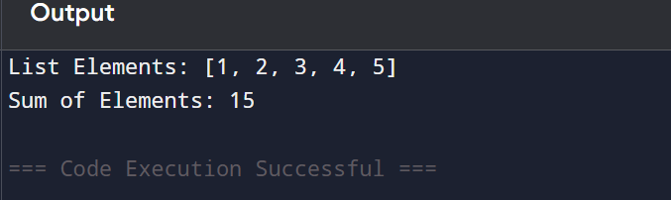

4. Function Returning Another Function
# Program demonstrating higher-order function
def multiplier(n):
return lambda x: x * n
double = multiplier(2)
triple = multiplier(3)
print("Double of 5:", double(5))
print("Triple of 5:", triple(5))
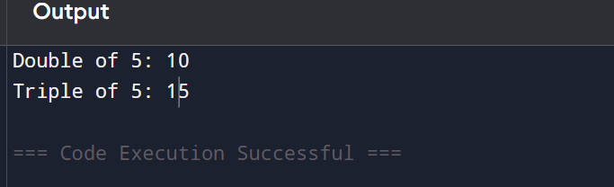

5. Using sorted() with Lambda Function
# Program to sort tuples using lambda
students = [
("Anu", 85),
("Rahul", 72),
("Priya", 90),
("Kiran", 78)
]
sorted_students = sorted(students, key=lambda x: x[1])
print("Students Sorted by Marks:")
for student in sorted_students:
print(student)

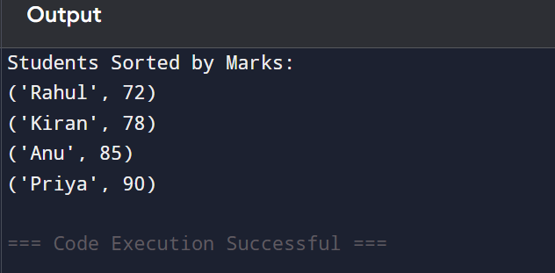

Using map() to Convert Strings to Uppercase
# Program to convert strings to uppercase using map()
names = ["anu", "rahul", "priya", "kiran"]
uppercase_names = list(map(lambda x: x.upper(), names))
print("Original Names:", names)
print("Uppercase Names:", uppercase_names)

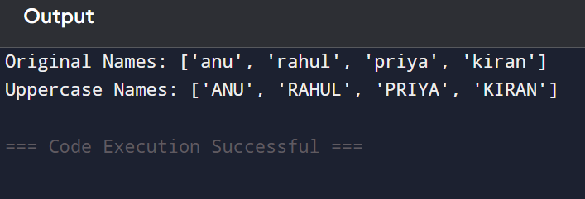

7. Using filter() to Find Positive Numbers
# Program to filter positive numbers
numbers = [-10, 20, -30, 40, 50, -60]
positive_numbers = list(filter(lambda x: x > 0, numbers))
print("Original List:", numbers)
print("Positive Numbers:", positive_numbers)
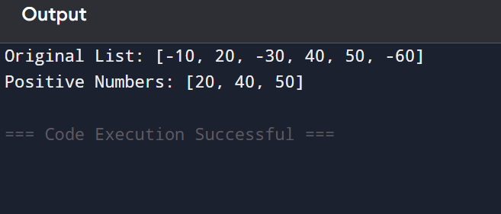

8. Using reduce() to Find Maximum Number
# Program to find maximum number using reduce()
from functools import reduce
numbers = [12, 45, 67, 23, 89, 34]
maximum = reduce(lambda x, y: x if x > y else y, numbers)
print("List Elements:", numbers)
print("Maximum Element:", maximum)

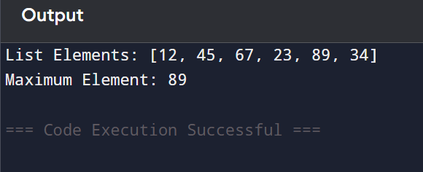

9. Lambda Function for Addition
# Program using lambda function for addition
addition = lambda a, b: a + b
num1 = 10
num2 = 20
result = addition(num1, num2)
print("First Number:", num1)
print("Second Number:", num2)
print("Sum:", result)

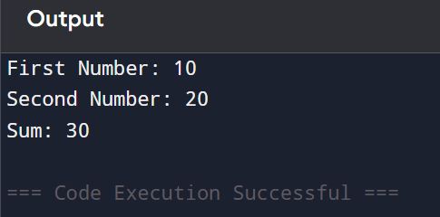

10. Using map() to Calculate Length of Strings
# Program to calculate length of strings using map()
words = ["Python", "Java", "C", "JavaScript"]
lengths = list(map(lambda x: len(x), words))
print("Words:", words)
print("Lengths:", lengths)
